Luis Franco 410921353

Homework 5

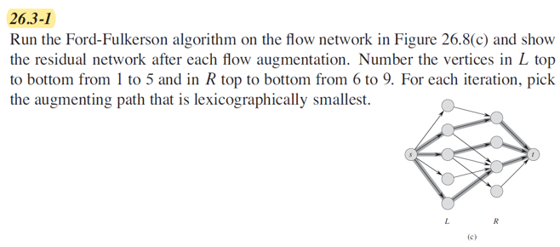

Assuming same weight for every edge (1):

Augmenting Path: S, 1, 6, t

Residual Graph

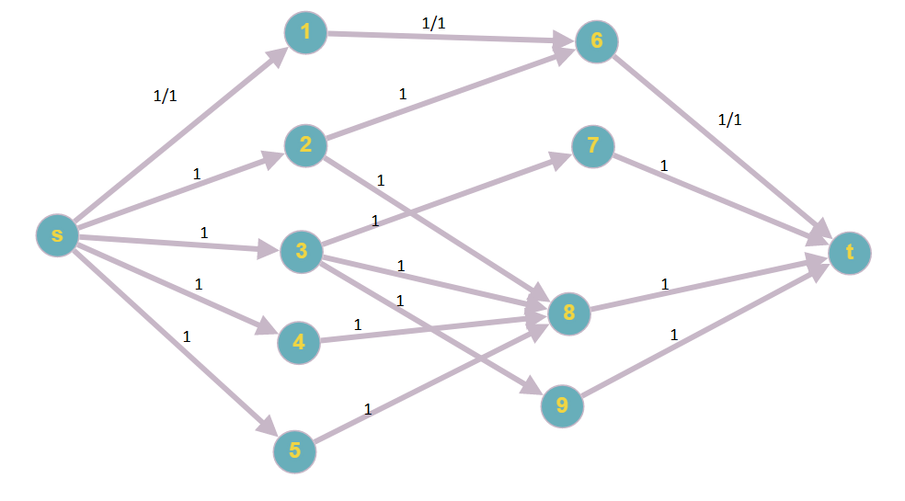

Augmenting Path: S, 2, 8, t

Residual Graph

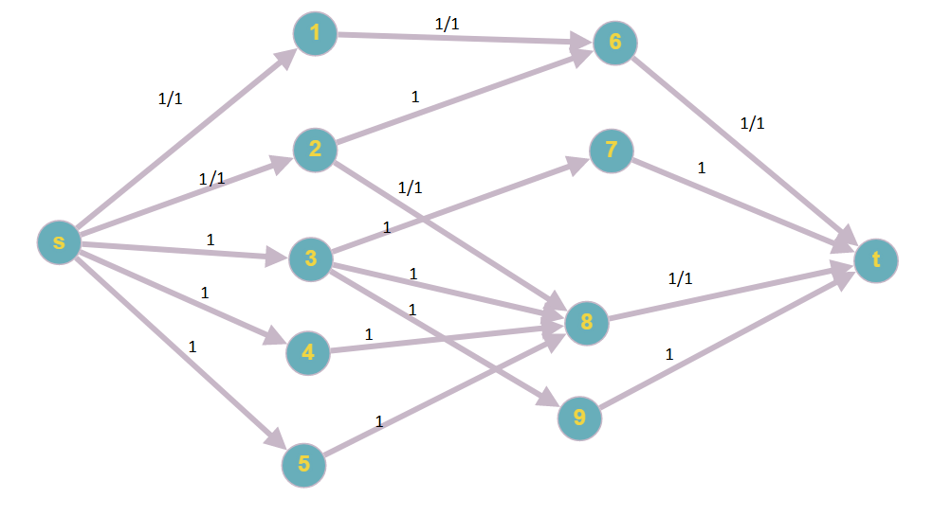

Augmenting Path: S, 3, 7, t

Residual Graph

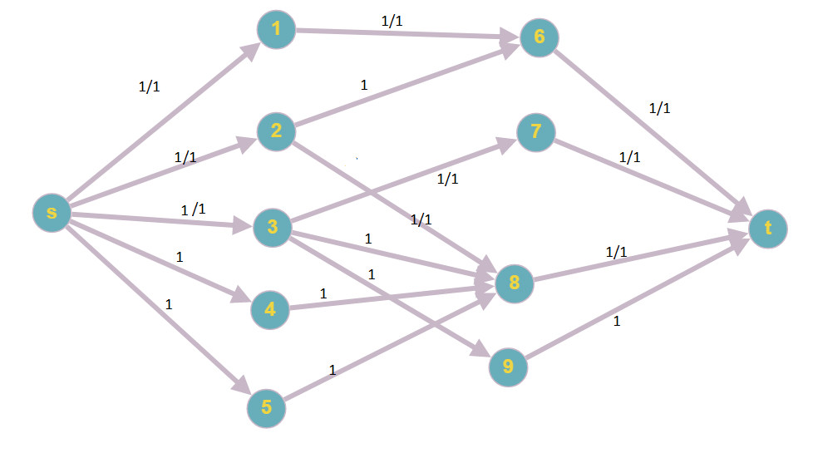

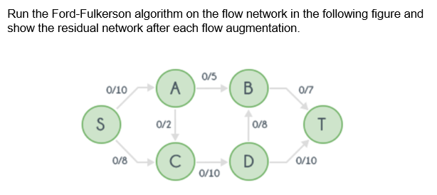

First augmentation:

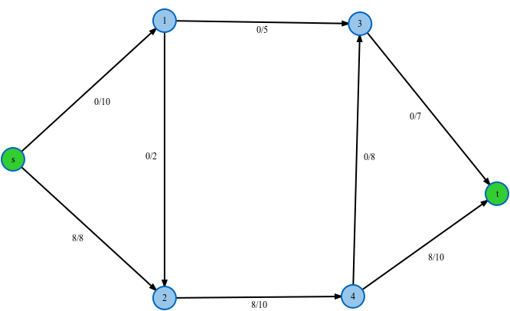

Residual Graph:

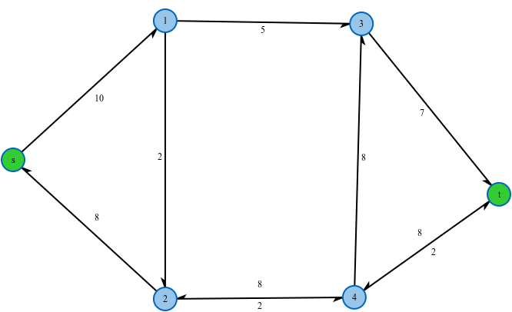

Second augmentation:

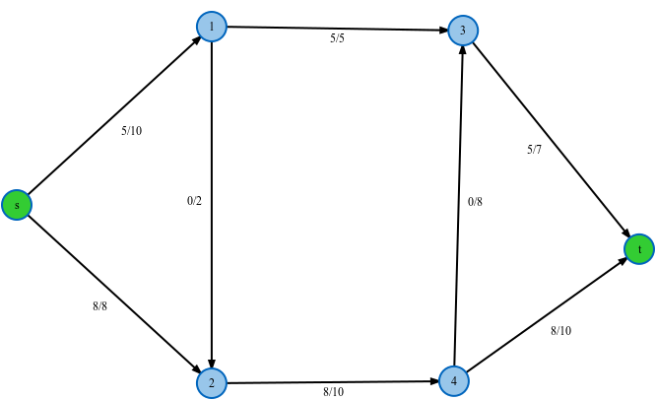

Residual Graph:

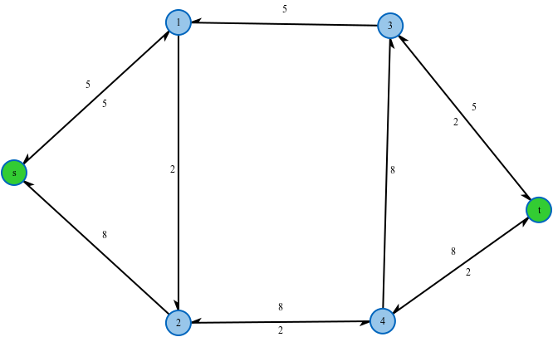

Third augmentation:

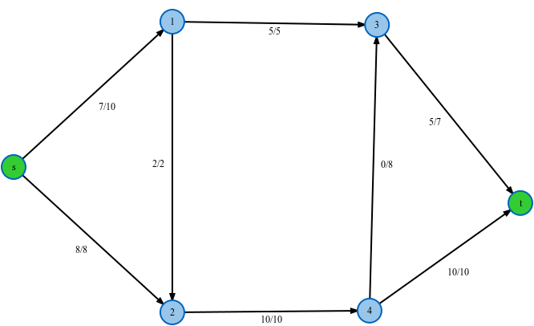

Residual Graph:

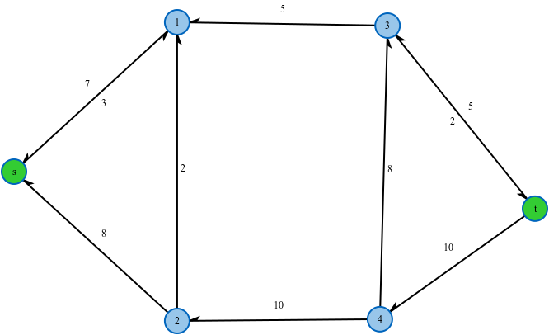

Result:



Max flow: 15